Part Pricer

User Documentation

Group 1

**Table of Contents**

Introduction ……………………………………………………………………………………. 3

Installation and setup ………………………………………………………………………. 3-4

How to Use …………………………………..………………………………………………… 5

Add New Material ……………………………………………………………………... 5

View Current Materials ……………………………………………………………….. 5

Save File ……………………………………………………………………………….. 5

Exit ……………………………………………………………………………………… 5

Summary ……………………………………………………………………………………….. 6

**Introduction**

Part Pricer is a simple text program, which runs through the terminal, that allows construction companies to enter in materials that they are using for a project. They enter in the quantity and the price of each unit. Part Pricer does all the calculations and allows the user to save the final estimates to a text document for easy reference.

**Installation and Setup**

Install the files for Part Pricer through github: <https://github.com/Skylar024/PartPricer.git>.

Once you have the files installed on your computer, open any IDE that can run C++ files and load in the whole folder. From there, you can run the program.

For this example, I will be using Visual Studio Code.

1. Open the folder by going file -> open folder… and locate the folder where you are holding the files

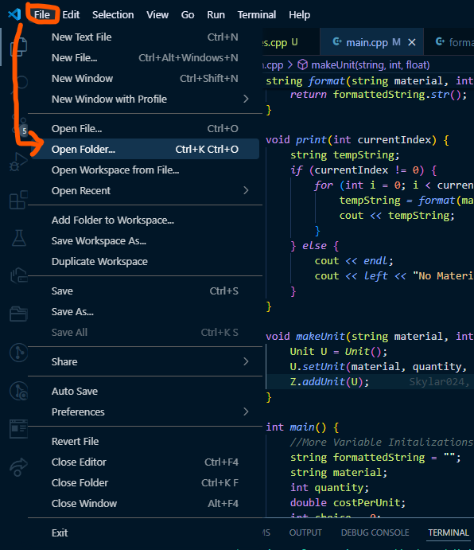

1. Go to run -> start debugging

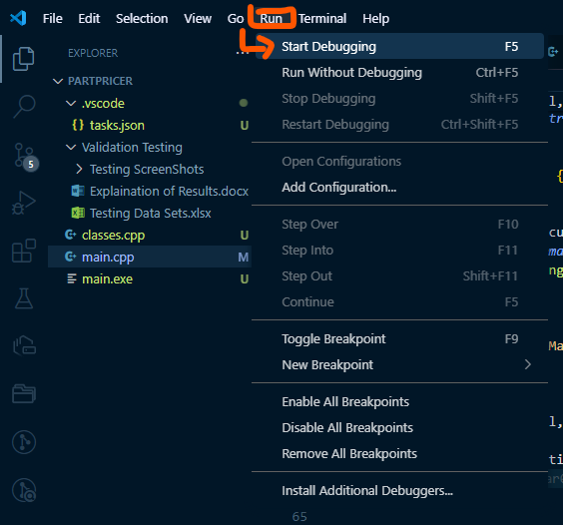

1. Down at the bottom of the screen, make you sure are under the terminal tab to see the program running

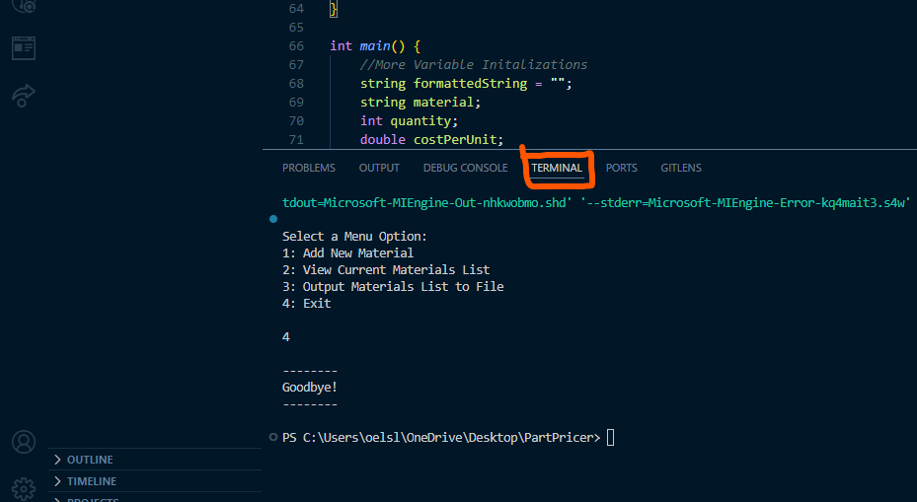

**How to Use**

In the terminal, you will get a list of options (1 - 4). Typing the number and pressing the enter button will allow it to run different functions of the program.

1. Add New Material

Choosing this option will bring up some prompts which you can answer and press enter after each answer. You will be asked to enter: material (ex. wood flooring), the quantity of this material you’re going to get, and the cost per unit.   
  
If you enter an invalid option, you will be told that it is an invalid input and the program will give the opportunity to enter another value.

When you finish, the information will be saved and you will be brought back to the 4 main options.

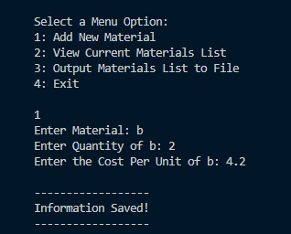

1. View Current Materials List

Choosing this option will show you a table of all the materials you have entered up until that point. It will display the name of the material, the quantity, the cost per unit, and the cost estimate of the material.

1. Output Materials List to File

Choosing this option will save a table of all materials you have entered and the total price estimate of all units to a text file within the same folder.

1. Exit

Choosing this option will close the whole program.

**Summary**